DAY-4
1.implement Linear Search Algorithm.
#include <stdio.h>
int linearSearch(int arr[], int n, int key) {
for (int i = 0; i < n; i++) {
if (arr[i] == key) {
return i;
}
}
return -1;
}
int main() {
int arr[] = {2, 5, 8, 12, 16, 23, 38, 56, 72, 91};
int n = sizeof(arr) / sizeof(arr[0]);
int key;
printf("Enter a key to search: ");
scanf("%d", &key);
int result = linearSearch(arr, n, key);
if (result != -1) {
printf("Key %d found at index %d.\n", key, result);
} else {
printf("Key %d not found in the array.\n", key);
}
return 0;
}
OUTPUT:
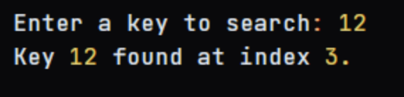
2.implement Binary Search Algorithm.
#include <stdio.h>
int binarySearch(int arr[], int low, int high, int key) {
while (low <= high) {
int mid = (low + high) / 2;
if (arr[mid] == key) {
return mid;
} else if (arr[mid] < key) {
low = mid + 1;
} else {
high = mid - 1;
}
}
return -1;
}
int main() {
int arr[] = {2, 5, 8, 12, 16, 23, 38, 56, 72, 91};
int n = sizeof(arr) / sizeof(arr[0]);
int key;
printf("Enter a key to search: ");
scanf("%d", &key);
int result = binarySearch(arr, 0, n - 1, key);
if (result != -1) {
printf("Key %d found at index %d.\n", key, result);
} else {
printf("Key %d not found in the array.\n", key);
}
return 0;
}
OUTPUT:
